Assignment Report  
Student Dropout and Academic Success Prediction using Machine Learning

short line

**Module Code:**

**Convenor Name:**

**Student Name:**

**Student Number:**

**Date:** 20 Feb, 2024

**Actual Hours Spent:** 30+ hrs (I work in 2 hour sessions, and take 5 min break every 30 mins. I needed 14 such sessions, and some extra work in between.)

# 

# **Abstract**

This report presents a predictive comprehensive analysis of student dropouts and academic success in higher education institutions via machine learning (ML). Utilizing a dataset from the UCI Machine Learning Repository, I applied three distinct machine learning models: Logistic Regression, Random Forest Classifier, and a Deep Learning model implemented with TensorFlow. The study aims to proactively identify students at risk of dropping out, allowing for timely intervention strategies.

# **Background and Problem Addressed**

The challenge in the educational sector to predict student dropouts and successes is critical. Proactive identification of at-risk students can lead to timely interventions, improving educational outcomes. At risk students can be offered special lessons or support to improve their chances of getting Graduated. This study leverages machine learning technologies to address these challenges, contributing to the burgeoning field of educational data mining.

# **Exploratory Data Analysis**

The dataset comprises 4424 instances with 36 features, including demographic, academic, and socio-economic factors. Initial explorations reveal a balanced representation of features like Marital Status, Gender, and others, with insights gained from distribution plots and correlation analyses.

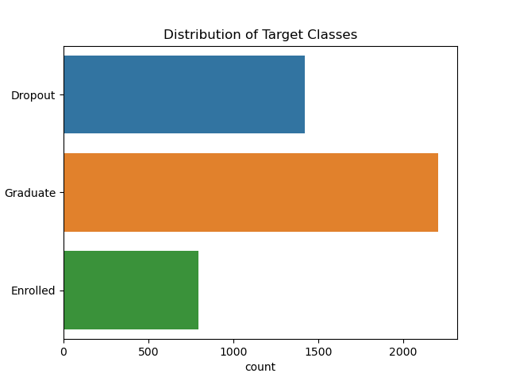This figure shows the imbalanced nature of our dataset, and as we can see, the Enrolled class has the least example, and our models have a harder time correctly finding this class.

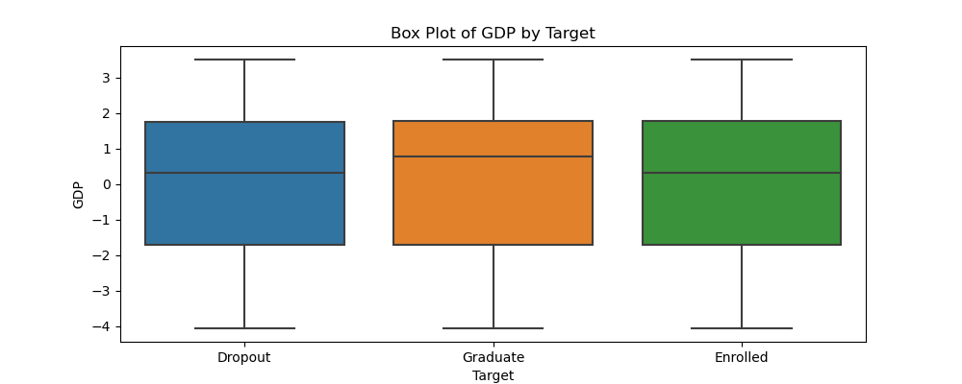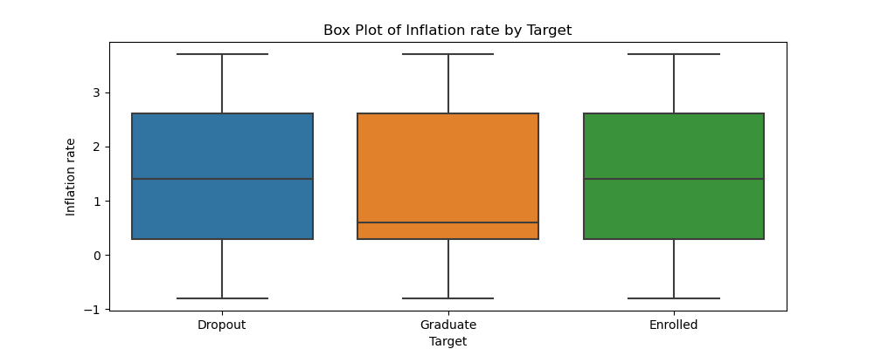

These figures show that current economic factors (GDP, Inflation) affect students' decisions. Then, we developed a feature that condenses these factors.We called it the Financial Stability Index. 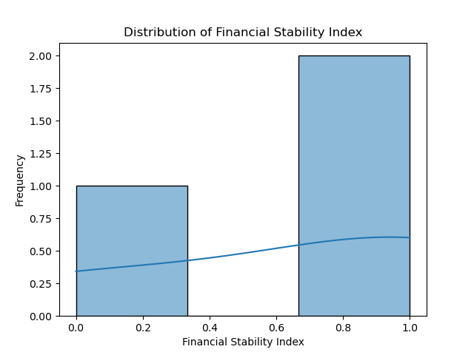

These figures show the imbalance of gender, international/national students, marital status and the admission grades.

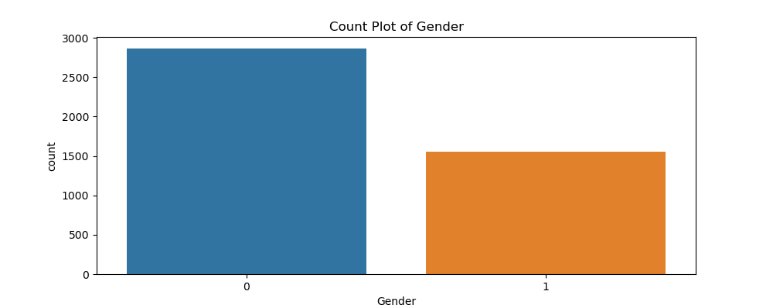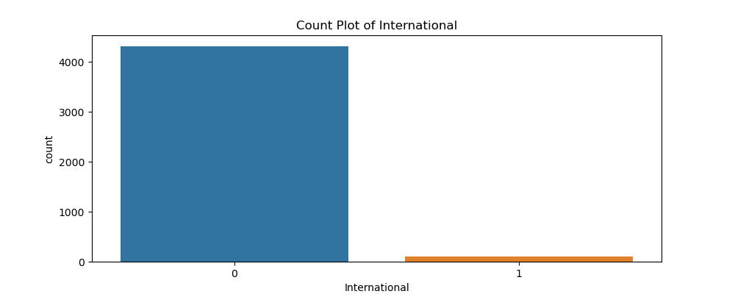

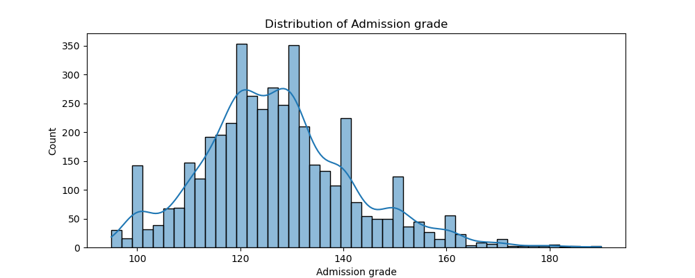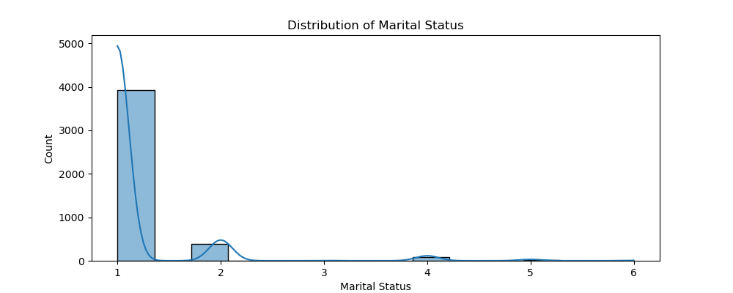

**The Heatmap Below shows which factors are Correlated to the target.**

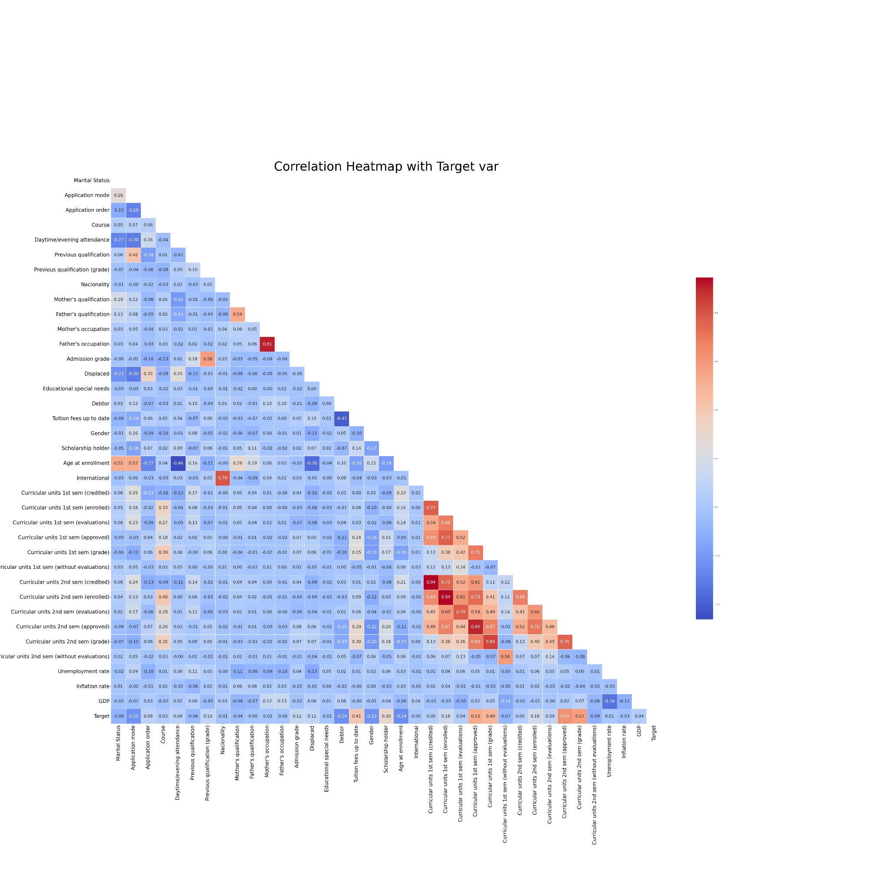

# **Data Pre-processing and Feature Selection**

Data preprocessing involved normalization, checking for missing values (there were none in the dataset), and encoding categorical variables. Feature engineering enhanced the dataset, introducing new features like 'Approval Rate' and 'Financial Stability Index' while ensuring the relevance and impact of each feature on the model.

**Machine learning models**

**Model 1: Logistic Regression**

* **Summary:** Employed for its interpretability and efficiency, serving as a baseline model.
* **Parameters:** max_iter=500.
* **Rationale for using the Model:** Selected for its simplicity and interpretability.
* **Training and Evaluation:** Achieved an accuracy of 75.25%, with a weighted precision of 73%.
* **Analysis:** Overall balanced performance but slightly lower compared to other 2 models.

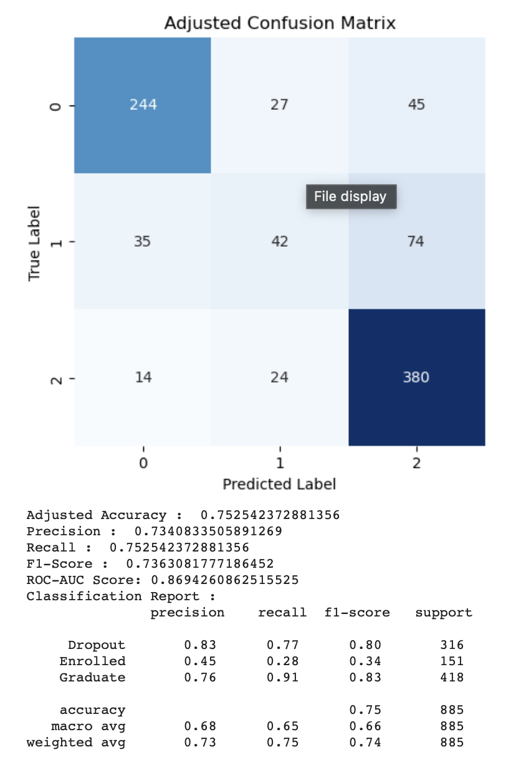

**Model 2: Random Forest Classifier**

* **Summary:** I made a Decision Trees model, and although very easy to build, it showed promising results, so I finally did a RFC model for its robustness against overfitting and ability to capture nonlinear relationships. Results similar to Logistic Regression indicate that the data aren’t nonlinear in nature.
* **Parameters:** Used default parameters.
* **Rationale for using the Model:** Robustness against overfitting, nonlinear pattern capturing capabilities.
* **Training and Evaluation:** Achieved the highest ROC-AUC score of 0.8714, indicating superior class differentiation.
* **Analysis:** The best overall performance. Some details here -

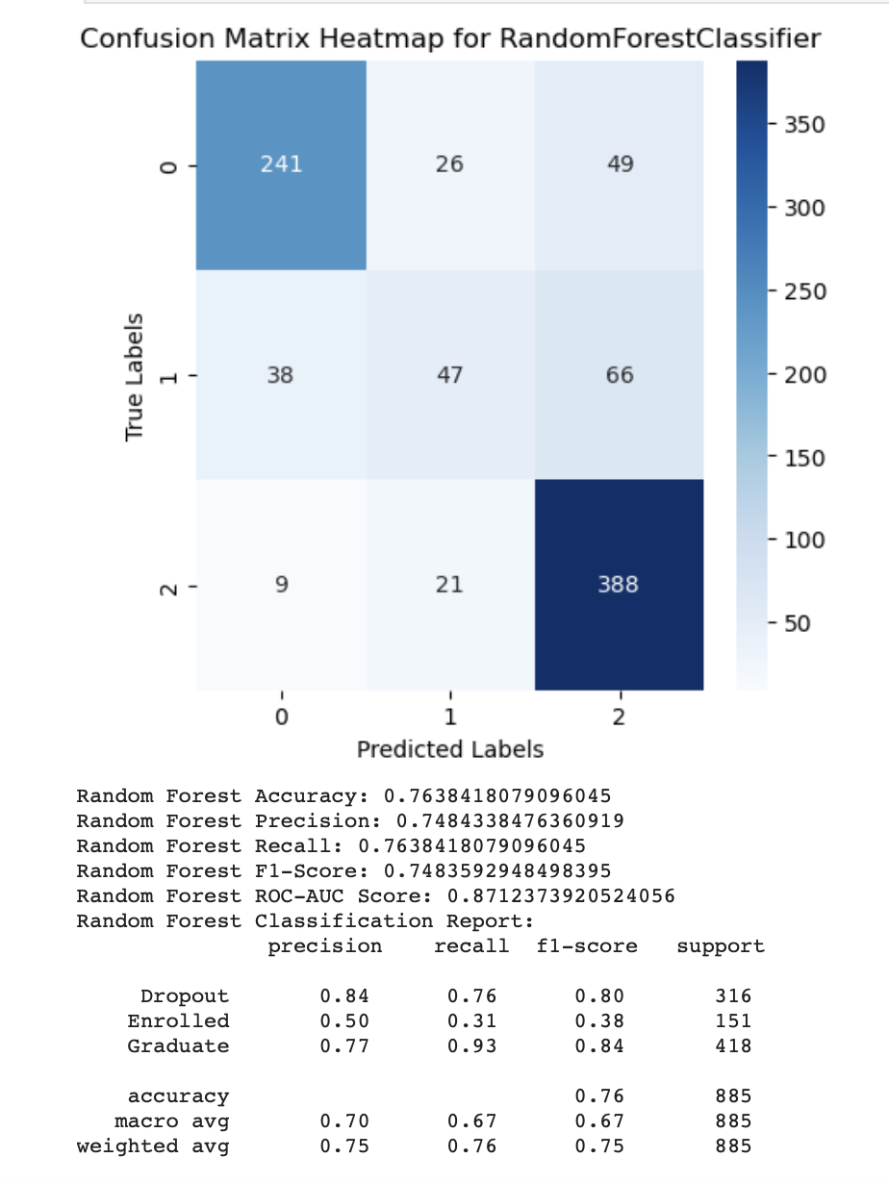

**Model 3: Deep Learning with TensorFlow**

* **Summary:** The model's architecture, focused on scalability, incorporates a sequential layout with multiple layers, each designed to progressively refine the learning from the data.
  + Structure : A Sequential model is employed, a common choice for a stack of layers where each layer has exactly one input tensor and one output tensor.
  + Layers : Dense layers form the core of this model. These layers are fully connected, meaning each neuron in a layer receives input from all neurons of the previous layer, enhancing the model's ability to learn complex patterns.
  + Activation Function : The 'relu' (rectified linear unit) activation function is used. Known for its efficiency and effectiveness, relu helps in mitigating the vanishing gradient problem, which is crucial for deep networks.
  + Regularization : L2 regularization is applied, aiming to prevent overfitting by penalizing large weights. This approach encourages the model to learn smaller weights, leading to simpler models that generalize better.
  + Dropout Rate A dropout rate of 0.5 implies that half of the neurons in a layer are randomly deactivated during training. This technique further combats overfitting by forcing the model to learn redundant representations.
* **Parameters:** Sequential model with Dense layers, relu activation, L2 regularization, and dropout rate of 0.5, Learning rate = 0.0001
* **Rationale for using the Model:** Adopted for its capability to model complex relationships.
* **Training and Evaluation:** The model has shown performance comparable to a Random Forest model, an encouraging sign given Random Forest's reputation for robustness. Achieving a ROC-AUC of 0.8663 is notable. This metric indicates good discriminatory ability.
* **Analysis:** I believe that with some proper tuning, maybe a different architecture, or hyperparameter readjustment could help DL models outperform the other ones. Here are the current results that I could push the model to (so far) -

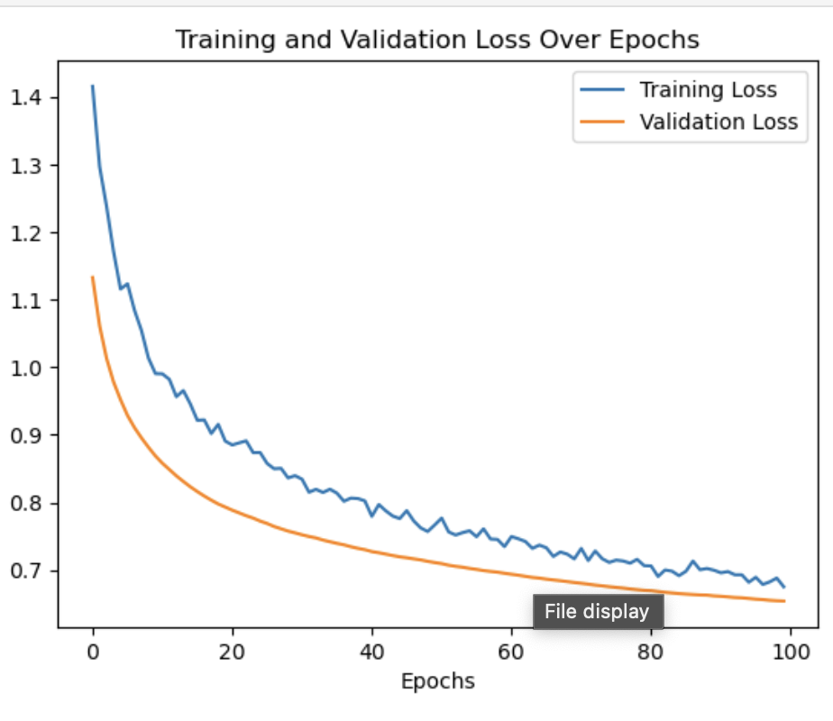

# **Performance Measures and Evaluation Strategies**

I've embraced a multifaceted approach to evaluate their performance. One of my go-to tools is the **ROC-AUC Score**, which brilliantly showcases a model's knack for distinguishing between various classes. To get a well-rounded view, I also lean on **Accuracy**, **Precision**, **Recall**, and the **F1-Score**. They provide a comprehensive and balanced view of how well my models are performing. Then there's the **Confusion Matrix** which offers insights into the classification accuracy across different categories.

# **Results Comparison and Analysis**

For this classification problem at hand, I crafted 8 models, each with its own pros and cons. I zeroed in on the top 3 for a more detailed study, finding that these models had a special knack for handling unseen test data. It was a close call, but the Random Forest stood out, not just in ROC-AUC and accuracy but across various metrics.

Deep Learning, with its complex neural networks, hinted at a vast potential yet to be fully tapped. Logistic Regression, though a bit more modest in performance, still held its ground with admirable effectiveness. These 3 models were very close to each other. Check the confusion matrices.

Gradient Boosting Machines (GBM) and Support Vector Machines (SVM) were like the strong, silent types – powerful and accurate. The Naive Bayes Classifier, with its simplicity, was surprisingly quick and accurate, showing promise in certain situations. K-Nearest Neighbors (KNN) and Decision Trees were reliable and straightforward – effective, simple, and quite insightful.

# **Conclusion, Recommendations, and Future Work**

Reflecting on this journey, it's clear that machine learning has a pivotal role in predicting student outcomes in educational settings. Each model brought something unique to the table, with the Random Forest Classifier emerging as the star. This exploration isn't just about numbers and algorithms; it's about paving the way for early intervention and better educational outcomes for students.

**Recommendations And Future Work:**

* **In-depth Analysis:** Looking ahead, I'm excited to delve into an in-depth Analysis of feature impacts and model behaviors.
* **Further Feature Engineering:** I'm thinking of diving deeper into Feature Engineering to give the models a sharper edge in predicting the 'Enrolled' category.
* **Model Tuning and Ensemble Methods:** A mix of Model Tuning and Ensemble Methods could be the secret sauce for even better performance.
* **Advanced Deep Learning Techniques:** I'm particularly keen on exploring Advanced Deep Learning Techniques – there's a whole world of neural network architectures just waiting to be discovered
* **Handling Class Imbalance:** And, of course, addressing Class Imbalance is key, especially for those underrepresented categories.
* **Cross-Validation Strategy:** Thiswill strengthen the robustness and interpretability of the models.
* **Ethical Considerations:** In educational settings, it's important to consider the ethical implications of predictive modeling. This includes ensuring fairness and avoiding biases that could adversely affect certain student groups. Future work could involve a thorough assessment of model biases and steps taken to mitigate them.

# **References**

1. Leo, Breiman. (2001). Random Forests. 45(1):5-32. doi: 10.1023/A:1010933404324
2. Lenis, Wong. (2023). Model for the Prediction of Dropout in Higher Education in Peru applying Machine Learning Algorithms: Random Forest, Decision Tree, Neural Network and Support Vector Machine. 116-124. doi: 10.23919/FRUCT58615.2023.10143068
3. Ioanna, Lykourentzou., Ioannis, Giannoukos., Vassilis, Nikolopoulos., George, Mpardis., Vassili, Loumos. (2009). Dropout prediction in e-learning courses through the combination of machine learning techniques. Computer Education, 53(3):950-965. doi: 10.1016/J.COMPEDU.2009.05.010
4. Tahira, Alam., Chowdhury, Farhan, Ahmed., Sabit, Anwar, Zahin., Muhammad, Asif, Hossain, Khan., Maliha, Tashfia, Islam. (2019). An Effective Recursive Technique for Multi-Class Classification and Regression for Imbalanced Data. IEEE Access, 7:127615-127630. doi: 10.1109/ACCESS.2019.2939755

short dash